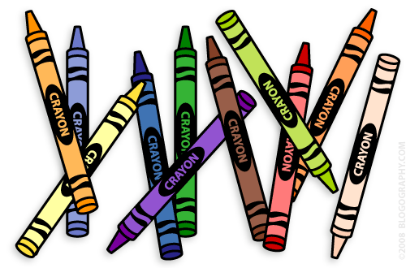**Our 1st Grade Classroom News**

**The Week of Nov. 7th – 11th**

**Email:** [**Lweeks@bluevalleyk12.org**](mailto:Lweeks@bluevalleyk12.org)

**Website:** [**www.bluevalleyk12.org/hes/lweeks**](http://www.bluevalleyk12.org/hes/lweeks)

- Red bag collection ends on November 15th. Please be sure to have your child bring in any money they want to donate for it by then! We have a little girl who is 6 years old that we are going to be buying gifts for! We have suggested that the kids offer to help around the house to earn money towards our red bag collection!

-We will be going to the book fair on Wednesday, November 16th from 12:45-1:10 as a class. This is time for the kids to buy all of the books they want! Students can bring in money that day to buy books on their own or you can join us in the library at that time to help them pick out their books.

-We are working on long i words spelled igh, ie, and y (ex: night, pie, fly).

-

**Important Info**

**Nov 15th** Red Bag Collection Ends

**Nov 16th** Class Visit to Book Fair @12:45pm

**Nov 23-25th** No School  
**Dec 6th** Early Release Day

**Dec 20th** ½ Day of School / Classroom Party (am)

**Dec 21-Jan 3rd** No School

**Upcoming Events**

**Tech of the Week**

**Website of the Week:** [Math Lines](http://www.sheppardsoftware.com/mathgames/mathlines/mathlinesmenu.htm)is a great game to practice addition, subtraction, or even multiplication if you think your child is ready for that. Students try to find the missing part to add to a certain number you set it at. <http://www.sheppardsoftware.com/mathgames/mathlines/mathlinesmenu.htm>   
 **App of the Week:** [Brain Tuner](https://itunes.apple.com/us/app/brain-tuner-lite-free/id287360582?mt=8) is great for addition and subtraction practice. Students have to decide whether a number sentence is right or wrong. Students can't go onto the next level until they have done well on the previous level. It starts with addition, then subtraction, and then a mixture of addition and subtraction.

**Challenges of the Week**

**Math Challenge of the Week:**We have recently been trying to write out our thinking as we are solving a problem. For example, if we were trying to solve 5+4+7, students might write, ‘I added 5+4 first because it was easiest and then added 7 to that to find the answer. I found out the answer is 16.’ Give your child a 3 addend addition problem like the example above. Then have them write a little bit about how they solved the problem. For this one, make sure they are writing, rather than you.

**Reading Challenge of the Week:** Recently we have been talking a lot about proper nouns and discussing how they are nouns that need to be capitalized. As your child is reading a book, have them make a list of proper nouns they find in it. Examples: Mrs. Weeks, Harmony Elementary, Overland Park, Snoopy, Taco Bell, etc.

**Writing Challenge of the Week:** We have been discussing recipes and the differences between ingredients and directions. The students wrote ingredients and directions on how they think a turkey should be cooked. Have your child write the ingredients and directions on how to make a peanut butter and jelly sandwich (or something they know how to make). Make sure in the directions they use transitional words such as first, next, then, finally.